700106 / 700120 Lab Book

Vulkan Exercises

Exercise 1: PREPARING THE APPLICATION FOR TEXTURES
Question: Update the application to support vertex normals and a new UBO for lighting data
Solution:
- The descriptor set layout remains binding 0 and VK_SHADER_STAGE_VERTEX_BIT, now used for model/view/proj plus lightPos and eyePos.
- After editing the GLSL, recompile to SPIR-V so the app can load shaders/vert.spv and shaders/frag.spv. Example:
- glslc -fshader-stage=vert SHADERS/shader.vert -o shaders/vert.spv
- glslc -fshader-stage=frag SHADERS/shader.frag -o shaders/frag.spv

What changed:
- Added normal to Vertex and third vertex attribute at location 2.
- Added lightPos and eyePos to UniformBufferObject and populated them in updateUniformBuffer.
- Replaced quad with a cube using per-face normals (no vertex sharing across faces).
- Implemented per-vertex lighting in the vertex shader; fragment shader outputs interpolated lit color.
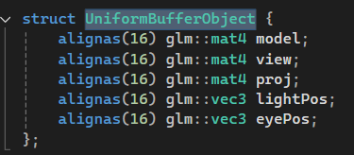
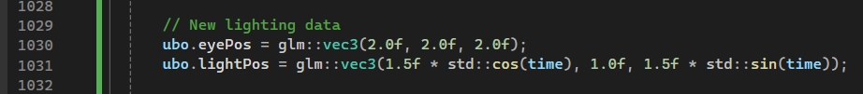
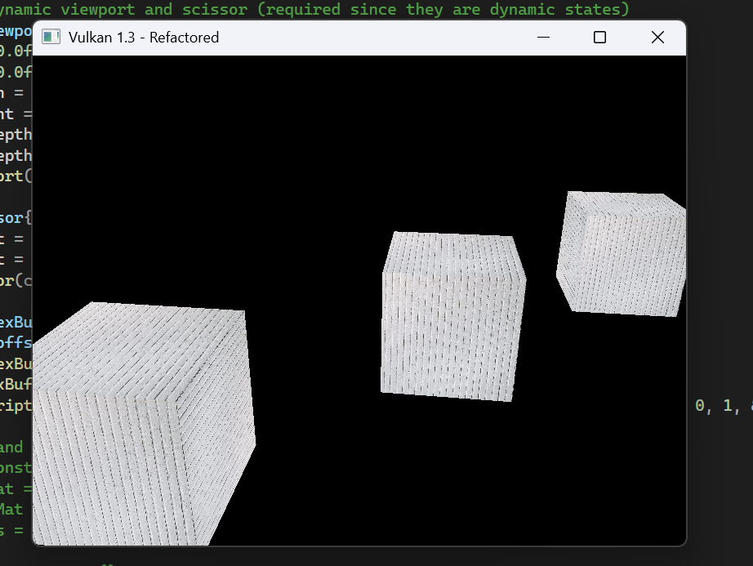

Exercise 2: PER-VERTEX DIFFUSE LIGHTING
Question: Implement a basic ambient and diffuse lighting model directly in the vertex shader.
Reflections:
- Getting lighting right requires consistent spaces: compute lighting in world space if you build worldPos with model and transform normals with the normal matrix transpose(inverse(mat3(model))).
- Shader interfaces must match exactly: location 0 out in the vertex must match location 0 in in the fragment; wrong names or locations won’t compile/link.
- UBO layout matters: using vec3 fields in std140 requires 16-byte alignment (your C++ UBO uses alignas(16), which prevents subtle layout bugs).
- Per-vertex lighting is fast but can look faceted on large triangles; finer meshes or per-fragment lighting smooths results at higher cost.

Questions:
- In Vulkan practice, when applying non-uniform scaling to the model matrix, is transpose(inverse(mat3(model)))

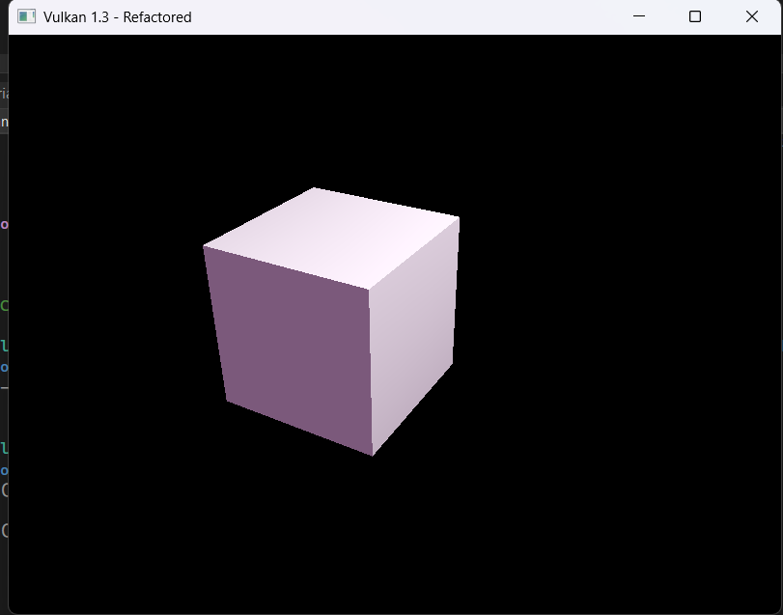
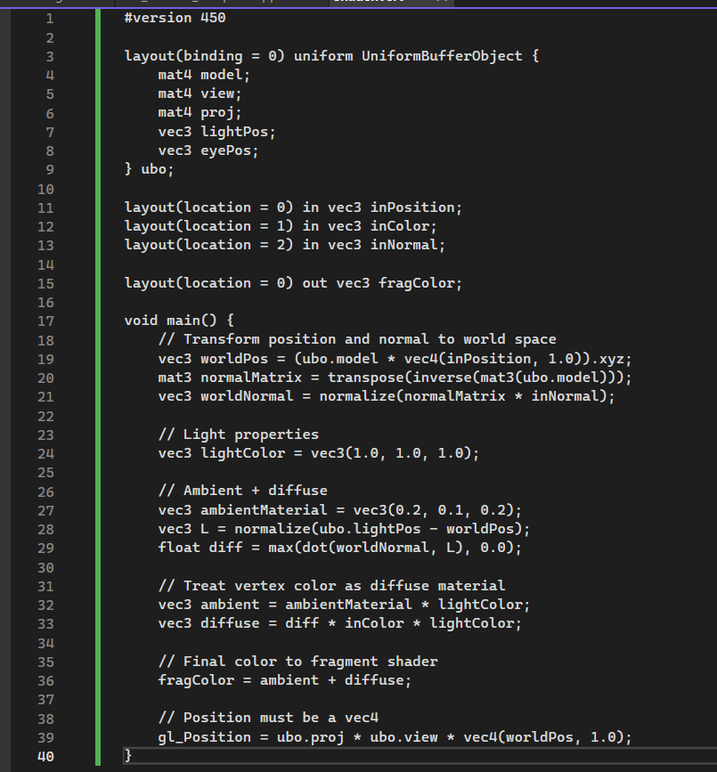

Exercise 3: PER-FRAGMENT DIFFUSE LIGHTING
Question: Improve visual quality by moving the lighting logic to the fragment shader, allowing for smoother, more accurate calculations.
Solution: Switched to per-fragment diffuse lighting. The vertex shader now only computes and passes world-space position and normal, plus the vertex color, to the fragment shader. The fragment shader receives those interpolated values and performs the ambient + diffuse calculation. Because the UBO is read in the fragment stage, the descriptor set layout in C++ must expose binding 0 to both the vertex and fragment stages. After making these edits, recompile your shaders to SPIR-V and rebuild.
Reflection: Moving lighting to the fragment shader immediately improves visual smoothness because the lighting is evaluated per-pixel using interpolated attributes rather than per-vertex with barycentric interpolation of the final color. The key to correct results is staying consistent in spaces: positions and normals are converted into world space, normals use the normal matrix transpose(inverse(mat3(model))) to remain accurate under non-uniform scaling, and the light direction is computed from these world-space values. Ensuring the UBO layout matches between C++ and GLSL (including 16-byte alignment for vec3 fields) prevents subtle artefacts, and updating the descriptor stage flags is required so the fragment shader can access the same UBO binding.
Question: In practice with Vulkan and modern GPUs, do you recommend performing normal transformation with the full normal matrix in the shader for every fragment, or precomputing a simplified or orthonormalized basis on the CPU when non-uniform scaling is present, considering the trade-offs between accuracy, numerical stability, and performance for real-time rendering?

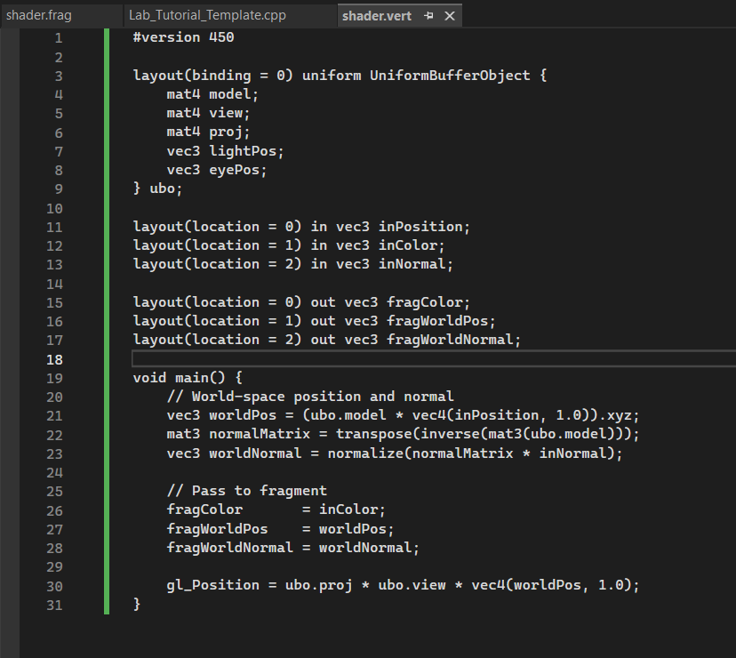
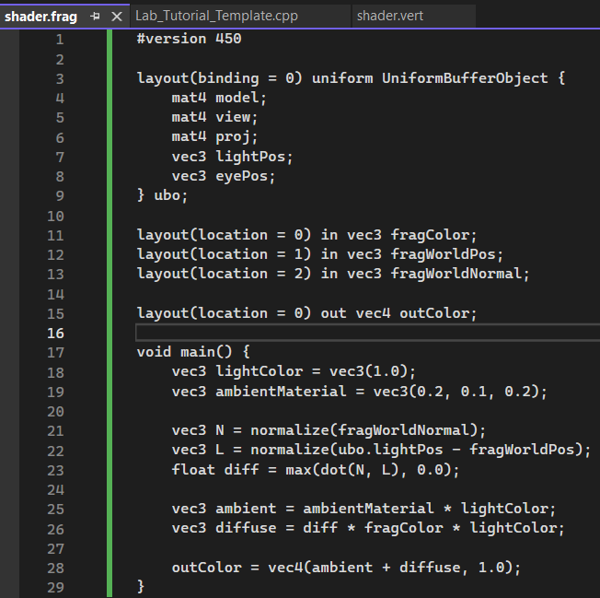
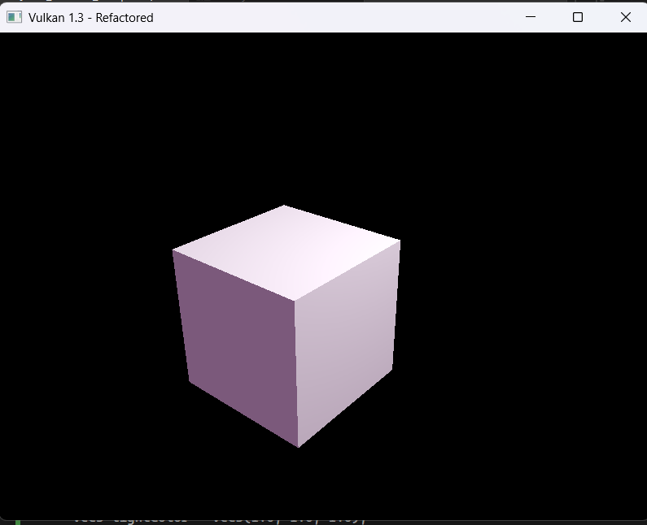

Exercise 4: ADDING PER-VERTEX SPECULAR LIGHTING
Question: Complete the reflection model implemented in Exercise 2 by adding specular highlights to the vertex shader.
Reflection: When targeting real-time pipelines, would you generally recommend Blinn-Phong (using a half-vector) rather than classic Phong reflection for the specular term in a per-vertex setup, and would evaluating in view space offer any practical benefits for numerical stability or performance compared to doing all specular math in world space as shown here?

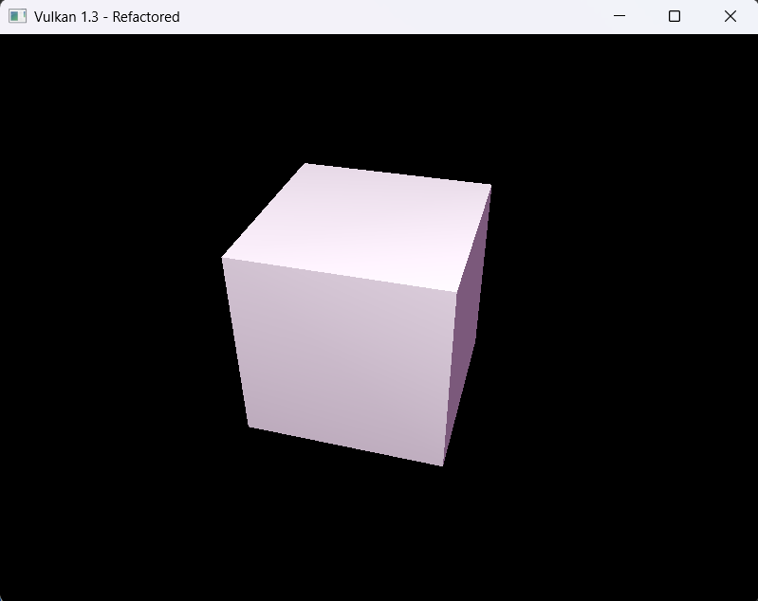

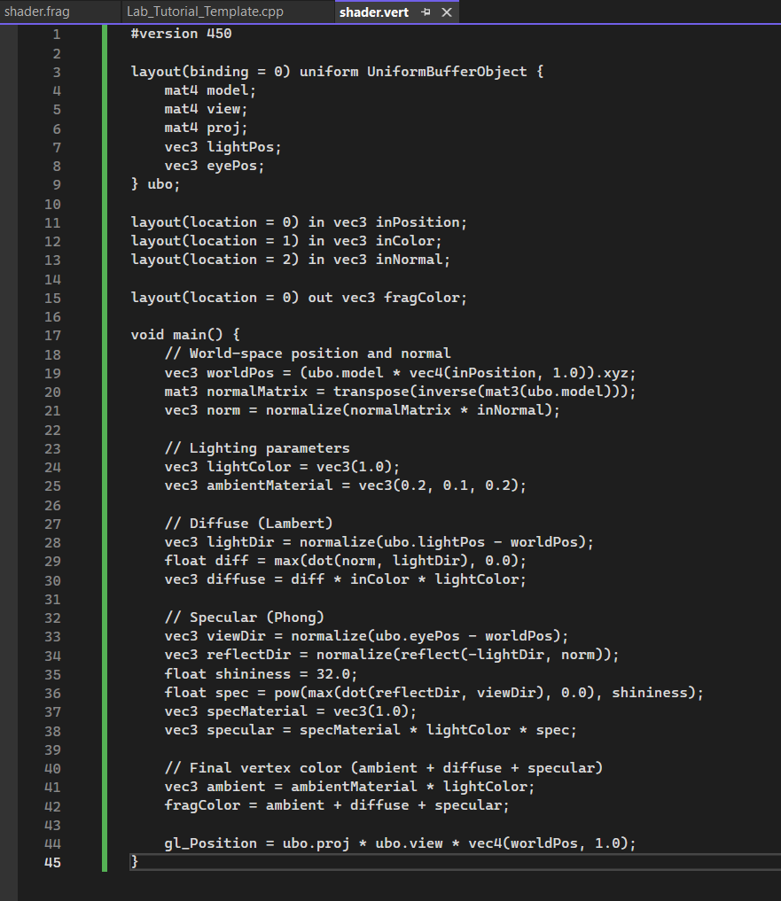

Exercise 5: ADDING PER-FRAGMENT SPECULAR LIGHTING
Question: Complete the reflection model implemented in Exercise 3 by adding specular highlights to the fragment shader.
Solution: I extended the fragment shader to compute the Phong specular term per pixel. This uses the interpolated world-space normal and position along with the camera position from the UBO. Also, ensure your mesh actually has valid normals; your current Cube_vertices lack normals and will default to zeros, which flattens both diffuse and specular.
Reflection: Moving specular to the fragment stage produces sharper and more accurate highlights because the non-linear specular term is evaluated per pixel instead of being linearly interpolated from vertices. However, this improvement is only visible if your mesh supplies correct normals and your UBO values reflect your camera and light configuration; zero or incorrect normals will smear or eliminate highlights, and a mismatched eyePos and view matrix will misalign reflections.

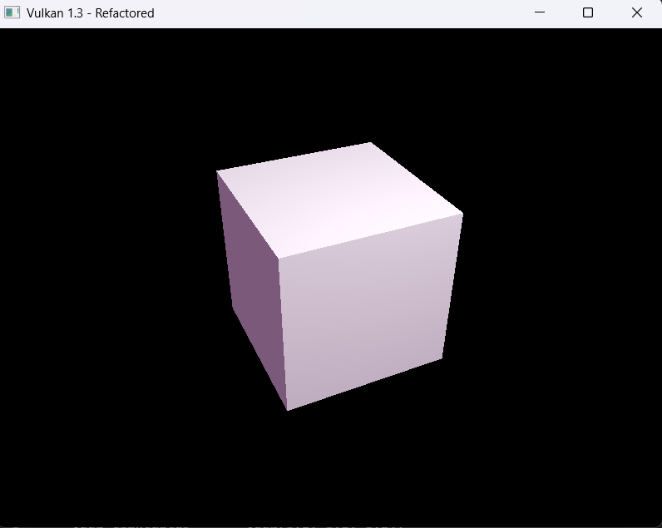

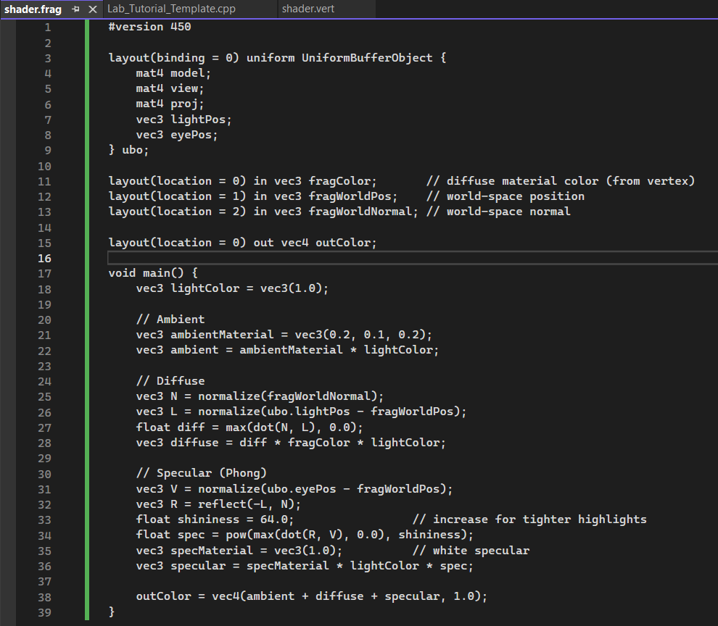

Exercise 6: MULTIPLE LIGHTS AND MATERIALS
Question: Draw three cube objects with three different surface material properties. Illuminate these cubes with two light sources: one is a static white light; the other is a red light rotating dynamically by the y-axis.
Solution: I extended the fragment shader to compute the Phong specular term per pixel. This uses the interpolated world-space normal and position along with the camera position from the UBO. Also, ensure your mesh actually has valid normals; your current Cube_vertices lack normals and will default to zeros, which flattens both diffuse and specular.
Reflection: This exercise introduced multiple light sources and material properties, showing how lighting equations are additive and modular.
By separating light and material data, it becomes easy to extend scenes for realism.
Animating a light by rotation adds dynamism and demonstrates how specular highlights react to light movement in real time.

Questions:
- What’s the computational cost of supporting multiple lights in fragment shaders, and how do engines typically optimize this (e.g., deferred rendering)?
- Is it more efficient to handle material variation via UBO updates per draw, or to use descriptor sets for each material?
- How would you extend this system to include attenuation (distance-based light falloff)?
